|  |  |  |  |
| --- | --- | --- | --- |
| Time | Session | | Location |
| 10:00-10:30 | **Registration and Refreshments.**  **Welcome and Introductions** | | St Chads College |
| 10:30-11:15 | **Research Talks**  *Dr Stuart Foyle – ‘*Religions, Worldviews and Disneyfication: Why Teaching and Learning Through Film is Important’ | OR  *Prof. Jonathan Miles-Watson – Title TBC* | St Chads College |
| 11:15-12:00 | **Research Talks**  *Prof. Chris Insole – Title TBC* | OR  *Prof. Francis Watson*  - ‘The making of the New Testament’ | St Chads College |
| 12:00-12:15 | **Break with refreshments** | | St Chads College |
| 12:15-13:00 | **Research Talks**  *Dr Georgina Robinson -* ‘Exploring death to better understand life’ | Or  *Prof. Alec Ryrie -* ‘The slave trade and the ethics of climate change’ | St Chads College |
| 13:00-14:00 | **Lunch and Networking** | | St Chads College |
| 14:00-14:45 | **Research Talks**  *Prof. Simon Oliver –* ‘Creation, gift, and the environmental crisis’ | OR  *Dr Guillermo Martin-Saiz* – ‘Why study Islam?’ | St Chads College |
| 14:45-15:00 | **Break with refreshments** | | St Chads College |
| 15:00-15:30 | **Classroom ideas**  *Group discussion* | | St Chads College |
| 15:30-16:00 | **Admissions to Durham**  *Lucy McCabe* | | St Chads College |
| 16:00 | **Thanks and Departure** | | St Chads College |

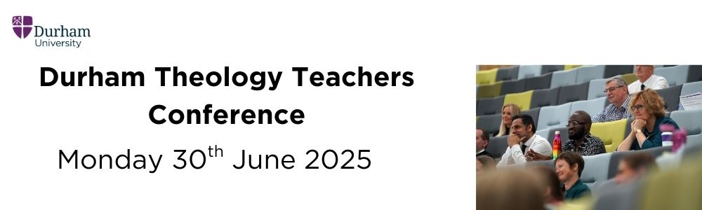

**Teaching and Learning Centre (TLC)**