Global theology conference: a brief report
Emmanuel College’s Global Theology Conference was held on the 3rd of September 2022, at Liverpool Cathedral.
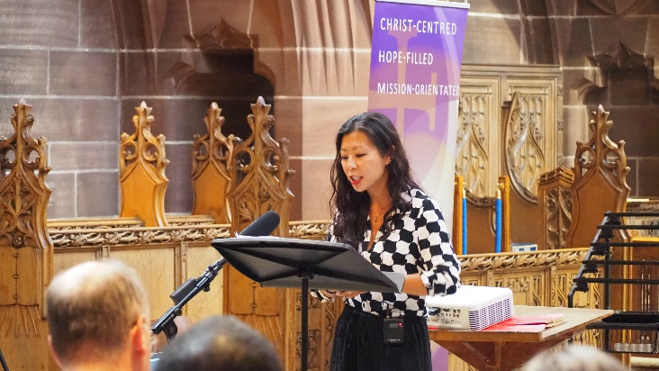
This gathering was extremely well attended by a wide spectrum of people from global majority heritage theologians and practitioners, TEI staff and students from around the country, clergy, and members of the wider public.
During the morning session we had three principal speakers: Revd Dr Isabelle Hamley, Revd Dr Carlton Turner and Dr Renie Chow Choy. Each talk was followed by a response from a practitioner (One parish priest, one ordinand and one curate) and a time for questions and answers from the audience. In the afternoon we had workshops on Dalit theology, the theology of loss and longing, church planting, a discussion on tackling racism within the Church of England, and a vocations session for those who were exploring ordained ministry with Church of England.
Later in the evening global majority theologians and practitioners met together for a fellowship meal and conversations about how to work together to implement the proposals in From Lament to Action. It was agreed to create a new forum and possibly think of future meetings and publication.
In the evening we had an inspiring keynote address by the Very Reverend Dr Kelly Brown Douglas.
We applied for seedcorn grant of £2000 to contribute to venue and conference speakers’ travel costs and we are grateful that this grant enabled us to bring high calibre global theologians and practitioners together.

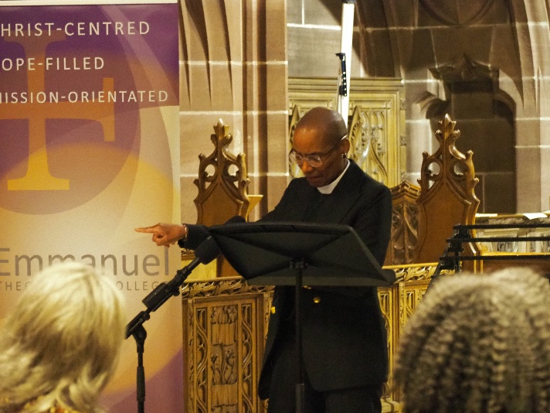
What did we achieve?
- An excellent conference first of its kind in the Northwest of England, which attracted people from all over the country.
- Taking in the advice from Seedcorn Grant Committee, we have produced professional quality videos of the lectures. There are currently being used as a teaching resource for Emmanuel College and we are exploring the possibility of offering them more widely after finalising the book project.
- Deepened our links with our international partner colleges. For example, Marthoma Seminary in India joined us for the evening Keynote address, despite this session starting at 2 am in India. Furthermore, The Very Reverend Dr Kelly Brown Douglas will be returning to be part of the Emmanuel College community for a term in autumn 2023.
- Global theologians network/ forum was agreed on and we are working towards a further gathering.
- Modelled good example of working on the recommendations in From Lament to Action
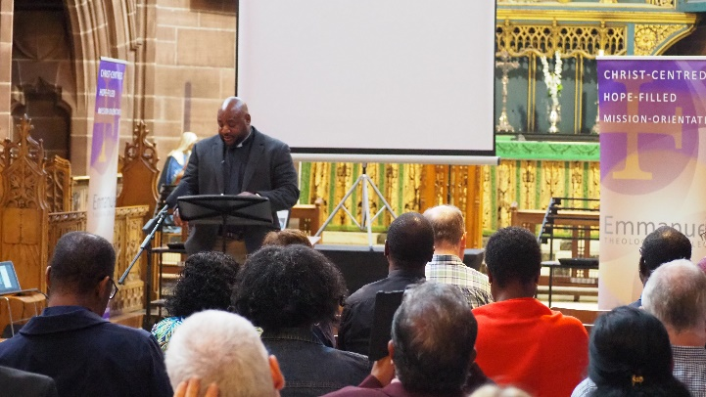
Further plans
- We continue to work on disseminating the conference papers trough the planned book and through the use of the videos.
- Strengthening our links with the global partners and continue to inspire and encourage our students to think globally.
- Supporting the Global theologians’ network.

